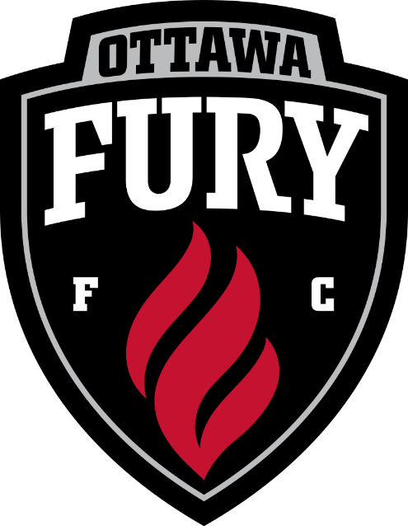
Ottawa Fury Russell Fun Day ! Come on out and join the Ottawa Fury vs Rochester Rinos and support the Russell Soccer Club. We will be providing buses for a fee that will be leaving Russell High School at 12:30pm
When: July 15th, 2017
Time: 2:00pm
Where: TD Place
For more information and to purchase tickets and bus tickets please contact Michelle at soccerisfun4life@gmail.com

